**.NET MVC Task**

**The Task**

Our client has recently acquired a new office building. Over 30+ companies are moving into this prime location. The building finds a need to develop a digital directory screen in the building lobby to display the company names.

Now the front-end designer has given you a web app UI design with mock data running. You are asked to enable the editing (CRUD) of this directory screen with MVC and connect it to the database.

**Tech Spec**

* There is a floating edit button on the left bottom corner. Your task starts there.



* Find a front-end inline editor plugin to implement the CRUD features in the Editor tab.

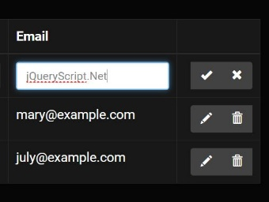

* Implement a logging framework (e.g. NLog/Log4Net) and display data change in the Log tab.
* Use .NET MVC and C# to build a Web Service interfacing the CRUD API.
* Use Entity Framework to properly model and manage SQL database.
* Create a simple microservice and deploy it to an endpoint in order to run the web app.
* Don’t worry about IE/Edge. It just have to run on a Chrome compatible browser.

Here is an example of the data structure:

**Log**

id: int

directory_id: int

field: string

from: string

to: string

datetime: date

**Directory**

id: int

company: string

level: string

suite: string

The building is now counting on you to conduct its business. Have fun coding! ;)